WORK-CASE №3

***Готував матеріал студент Мішин А.О.***

*1. In the Virtual Box, VMWare Workstation (or another virtual machine of your choice), you need to run:*

*- Clone your virtual desktop OS (Work-case 2). How can this be done? Follow the steps below*

*- It may be necessary to transfer (clone) the OS to another virtual environment. What steps do you need to take to export your virtual desktop OS?*

**To clone a virtual machine in VirtualBox and export it to another virtual environment, follow these steps:**

**Clone a virtual machine in VirtualBox:**

**- Open VirtualBox and make sure that the virtual machine you want to spawn is not running.**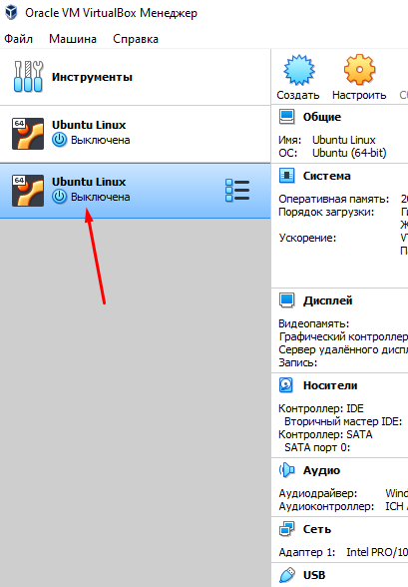

**- Select the virtual machine in the list of machines in the left pane.**

**- Right-click the selected virtual machine and select Clone**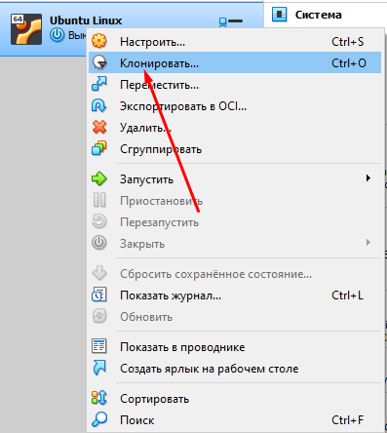

**- Select a name and location for the new cloned virtual machine. You can also choose whether you want the machine's UUID to be re-generated. Once you're done, click Next.**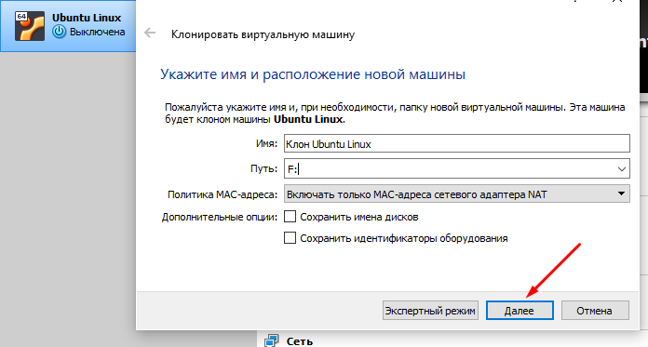

**- Select the cloning options. You can choose Full clone, which will create a copy of the virtual machine with all the files, or Linked clone, which will be a link to the original machine. After selecting the options, click Clone.**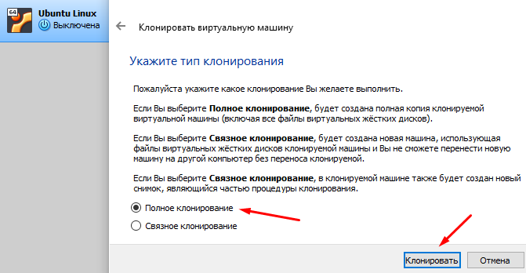

**- You now have a clone of the virtual machine, and it can be selected and launched from the list of virtual machines in VirtualBox.**

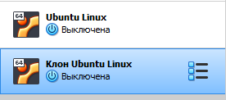

**Exporting a virtual machine:**

**If you want to export your virtual machine for subsequent import into another virtual environment, follow these steps:**

**- Open VirtualBox again.**

**- Select the virtual machine you want to export in the list of machines in the left pane.**

**- Right-click on the selected machine and select Export Appliance.**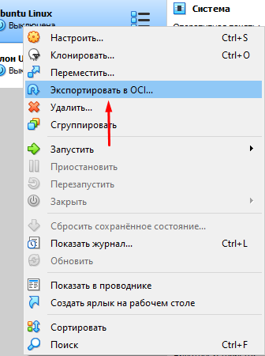

**- Select a path to save the exported OVA (Open Virtualization Format Archive) file. This is a standard format for exporting and importing virtual machines between different environments.**

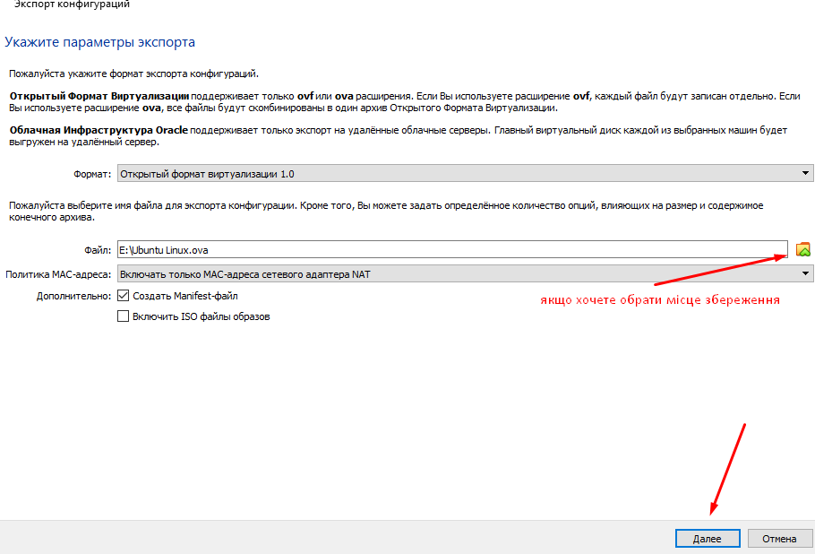

**- Configure export settings, such as CPU or memory limits, if necessary.**

**- Click Next and review the settings. Once you're satisfied, click Export.**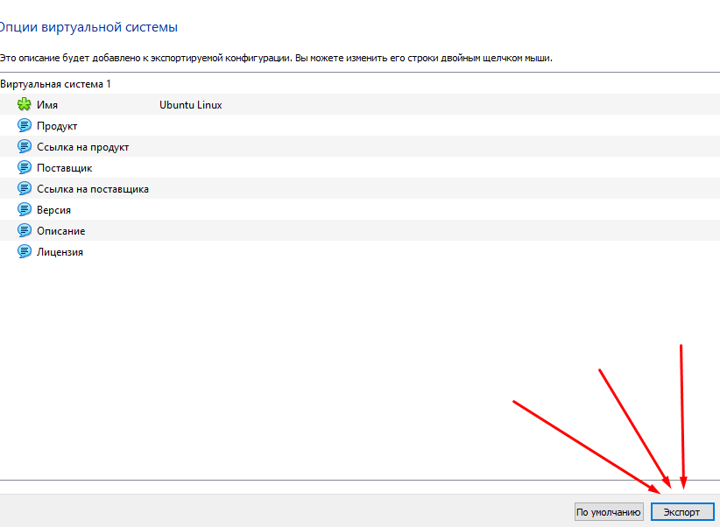

**When the export is complete, you will receive an OVA file that can be transferred and imported into another VirtualBox or other virtualized environment.**

***2. In the course of work, one working virtual machine can interact with another. To do this, you need to deploy a network between them. Describe what types of network connections are supported in the virtual machine environment, what is the feature of each of them:***

**- Network Address Translation (NAT);**

**- Network bridge (Bridged);**

**- Virtual host adapter (Host-only);**

**- Internal Network.**

VirtualBox supports several types of network connections between virtual machines:

**1.Network Address Translation (NAT):**

- When you configure a virtual machine for NAT, VirtualBox creates a virtual router that allows virtual machines to access the Internet through the host OS, but they are not visible from the external network environment.

- Virtual machines on a NAT network have their own internal IP addresses, and all network traffic is routed through the NAT.2.Мережевий міст (Bridged):

- In Bridged mode, the virtual machine connects directly to the physical network. This means that it can see and be seen by other devices on your network, as long as they belong to the same subnet.

- The virtual machine gets its own IP address on your physical network, and it can communicate with other devices if their network configuration allows it.

**3.Virtual host adapter (Host-only):**

- In this mode, virtual machines can communicate with each other and with the host operating system, but they do not have access to an external network or the Internet.

- Virtual machines connected to a Host-only network get their own IP addresses and can communicate with each other and with the host OS over the local network.

**4.Internal Network:**

- This type of network is designed to create an internal network within VirtualBox to which virtual machines can be connected, but they do not have access to an external network or the Internet.

- An internal network is useful when you need to create an isolated network between virtual machines, but you don't want them to be able to communicate with external networks.

***Готував метеріал Нерощин Данііл***

*3. Deploy a network between your working OS and its clone (Task 1):*

*- Demonstrate the basic commands to configure the network settings of the OS and explain what they do.*

*- Both operating systems must have access to the Internet. Open a browser and watch any video on youtube*

*- Configure and demonstrate the exchange of messages between the two OSes over a local network. What commands do you need to enter in the terminal?*

*- Set up a shared network folder for both OSes. Try copying files from this directory to the user's home directory (virtual desktop) and to the desktop (clone of the virtual desktop).*

Set up a shared network bridge between the OS and its clone:

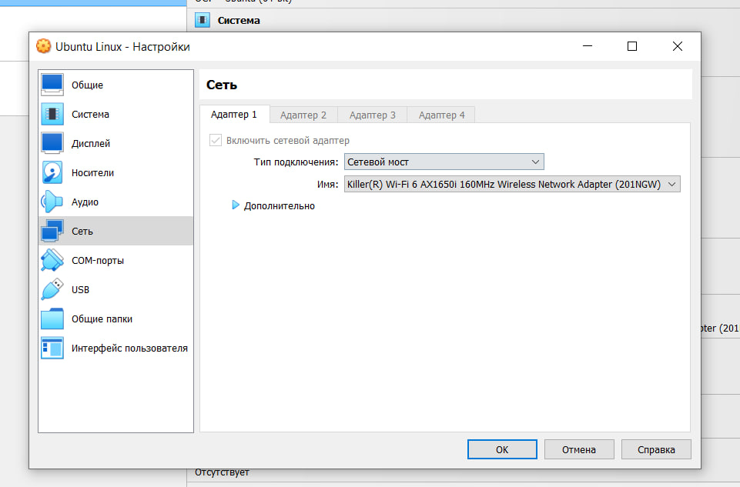

In the terminal, enter the command "ip a" and check whether the IP is shared between the two OSes:

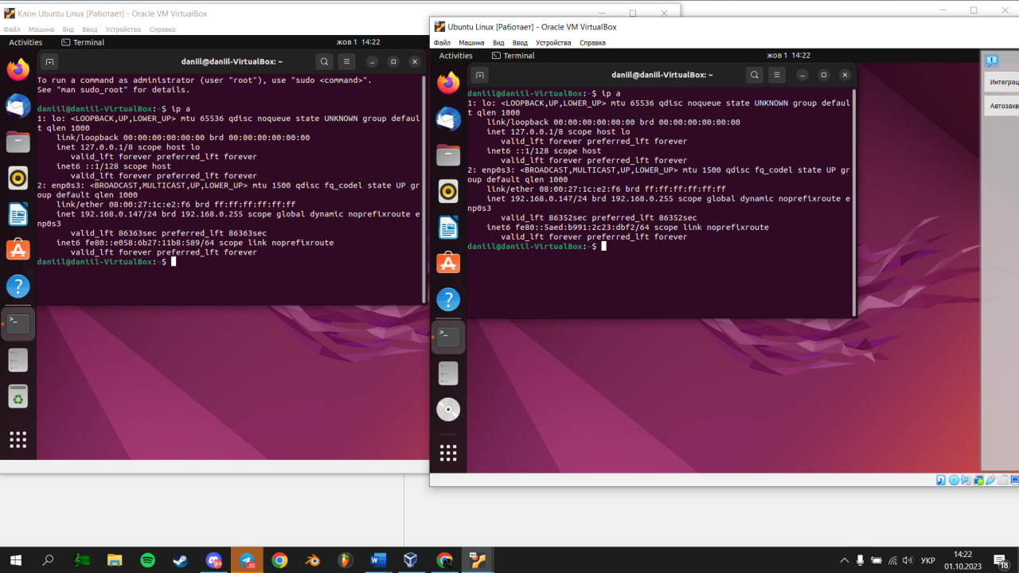

Go to YouTube and see what is connected to the Internet.

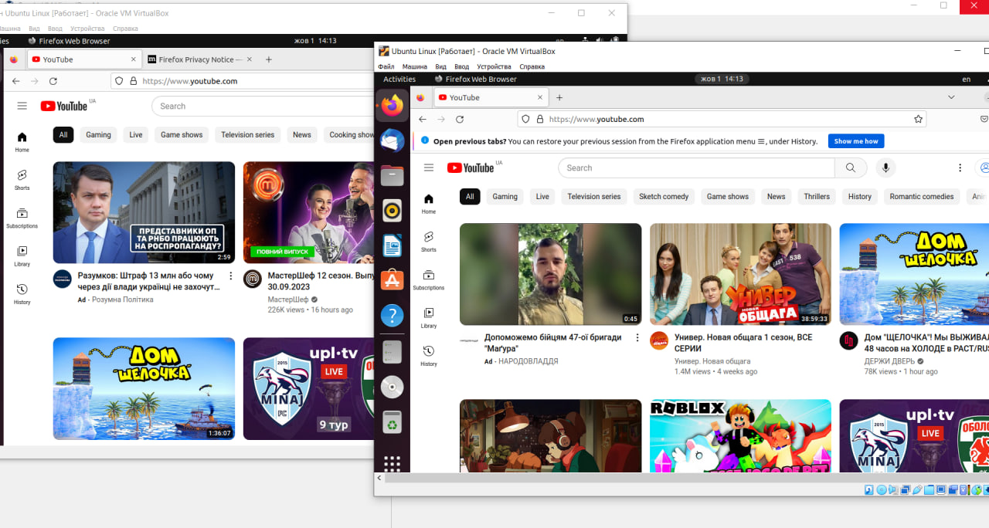

Play videos on two operating systems

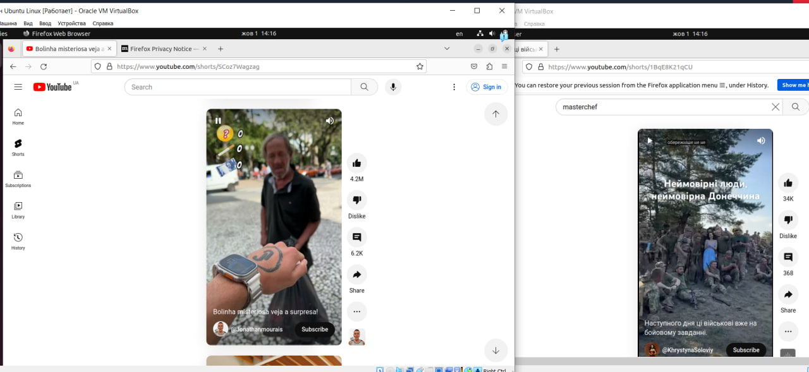

To set up a shared folder between two virtual machines running the Ubuntu operating system, you can use VirtualBox and virtual machines running Ubuntu on this platform.

- In VirtualBox, select the virtual machine for which you want to set up the shared folder.

- Right-click on the selected virtual machine and select Settings.

-In the Settings window, select Shared Folders from the left menu.

-Click the plus folder icon on the right and add a new shared folder by specifying the path on the host machine and the name of the shared folder

Mounting a shared folder in Ubuntu:

In each Ubuntu virtual machine, open a terminal.

Create a folder where you want to mount the shared folder. For example:

sudo mkdir /mnt/shared

Mount the shared folder using the mount command. For example:

sudo mount -t vboxsf SharedFolderName /mnt/shared

Replace SharedFolderName with the name of the shared folder you created in VirtualBox.

You can now share files between virtual machines and the host machine through the shared folder you configured.

***Готувала матеріал Малієнко Аліна***

***4. To organize the exchange of information between the main operating system (for example, Windows) and Ubuntu virtual operating systems, you can use a shared folder, a network connection, or other methods. Here are some ways to do this:***

Shared folder in VirtualBox:

Use VirtualBox's ability to set up a shared folder between the main operating system and the Ubuntu virtual machine, as described in the previous answer.

Network connection:

Configure the network connection between your main operating system and the Ubuntu virtual machine. You can use the "Bridged Adapter" in the network settings in VirtualBox to make the virtual machine available on the same network as your main operating system. You can then use network protocols (e.g. SSH, FTP) to exchange files and data between the systems.

Other methods of file sharing:

Use cloud services or email to exchange files between operating systems. For example, upload files to cloud storage (e.g., Google Drive, Dropbox) and download them from another operating system.

USB ports in VirtualBox:

Use VirtualBox's ability to share USB ports between the host operating system and the virtual machine. This will allow you to connect USB devices (such as flash drives) to the virtual machine and share data through this method.

Choose the exchange method that best suits your specific case and requirements.